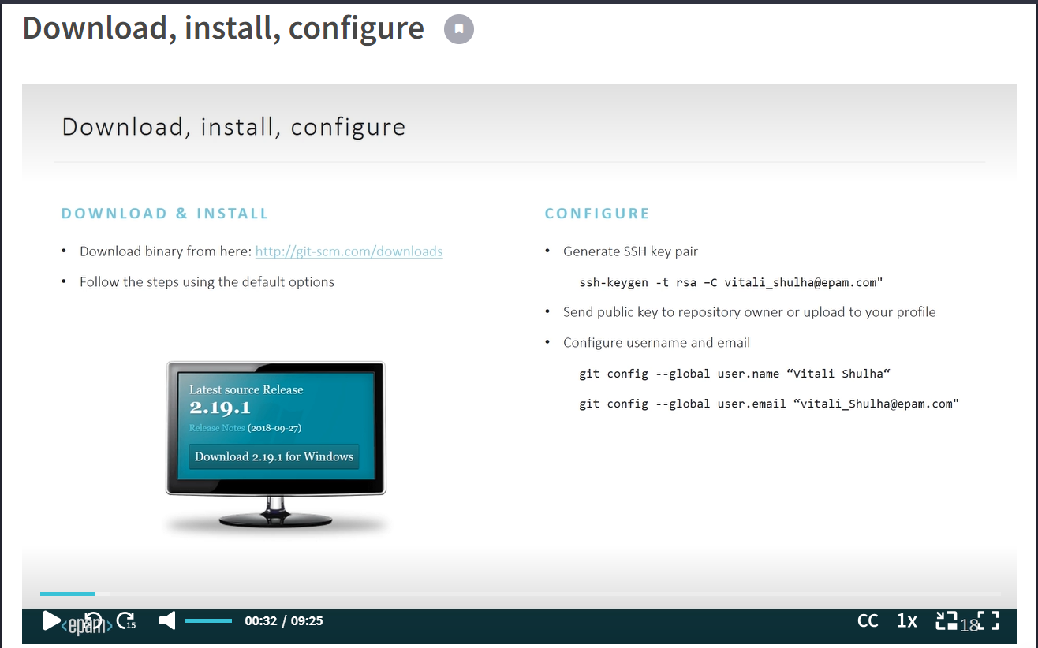

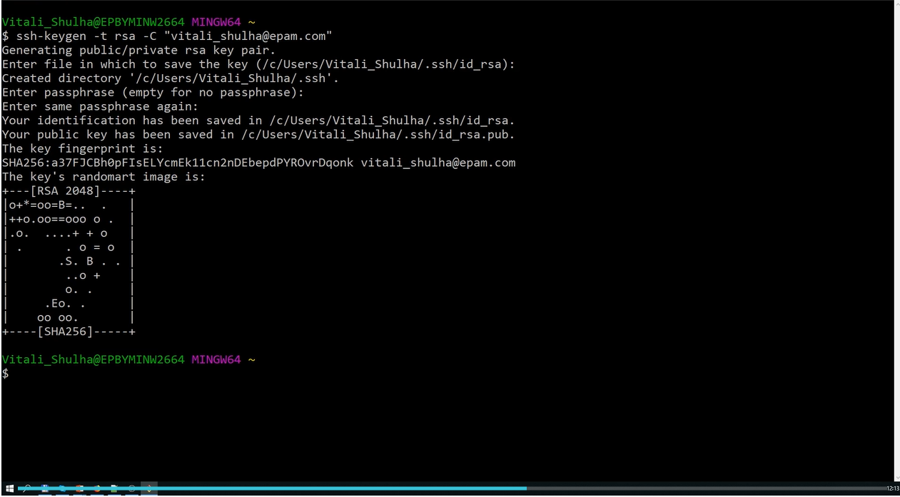

NOTE: Don’t share Private SSH Key to anyone, we can share Public SSH key

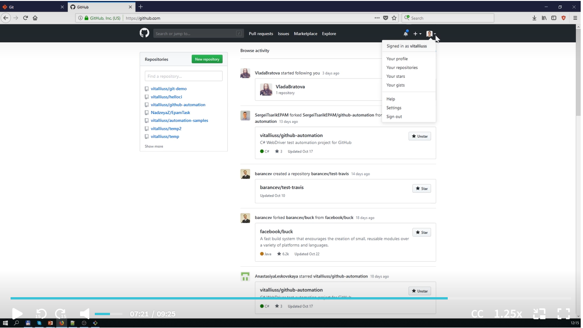

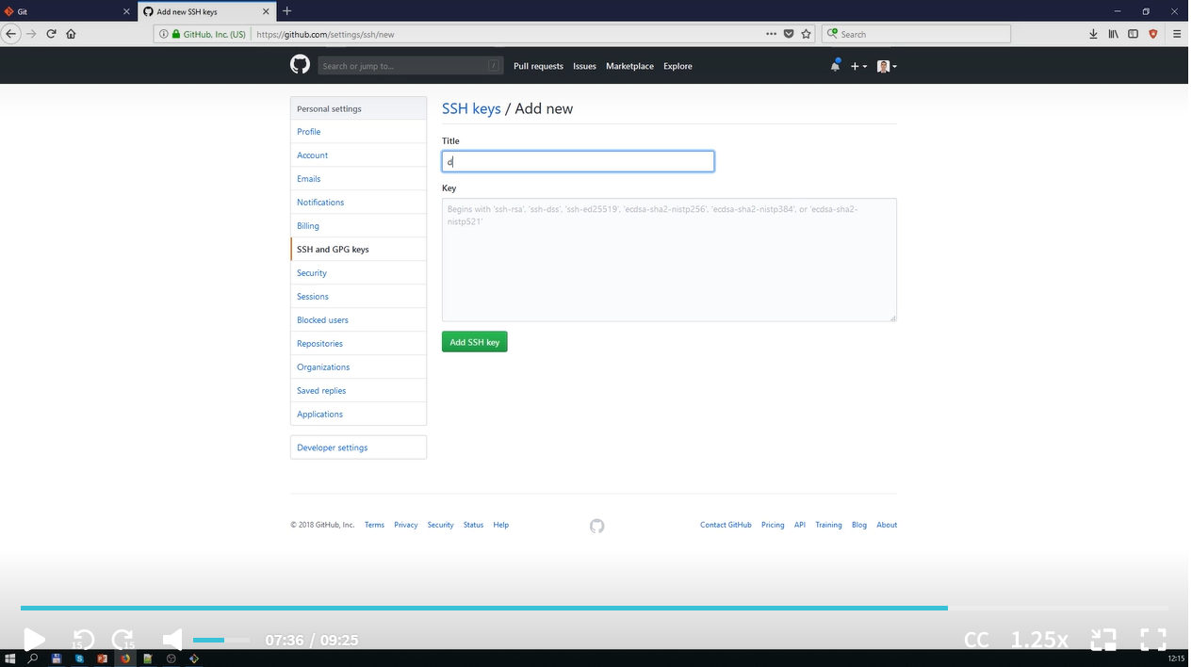

GIT Gui and Gitk:

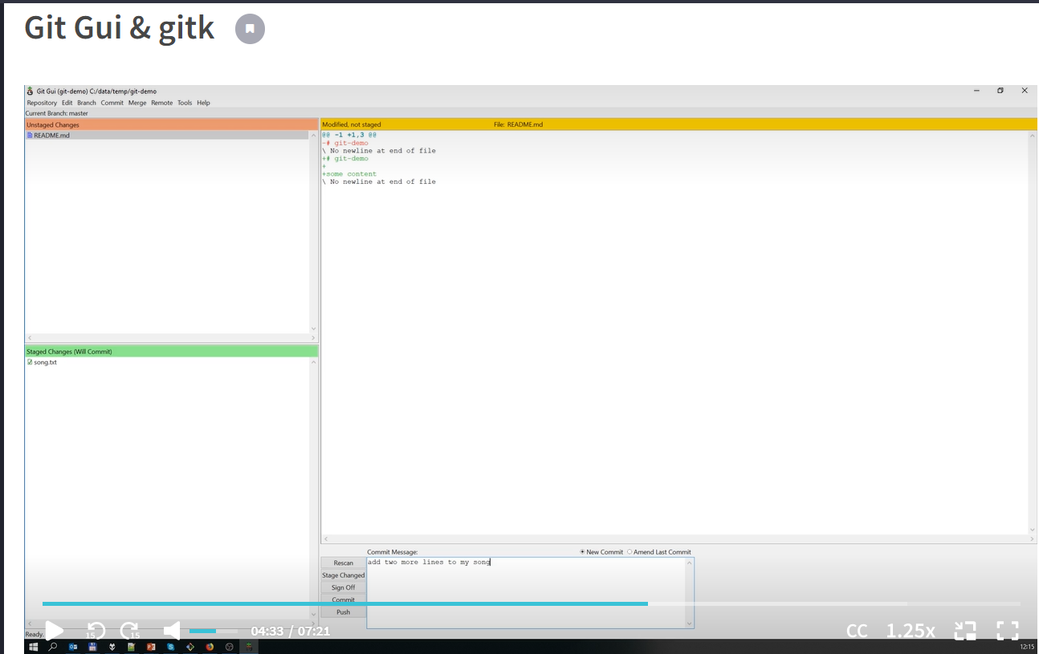

Undoing Changes:

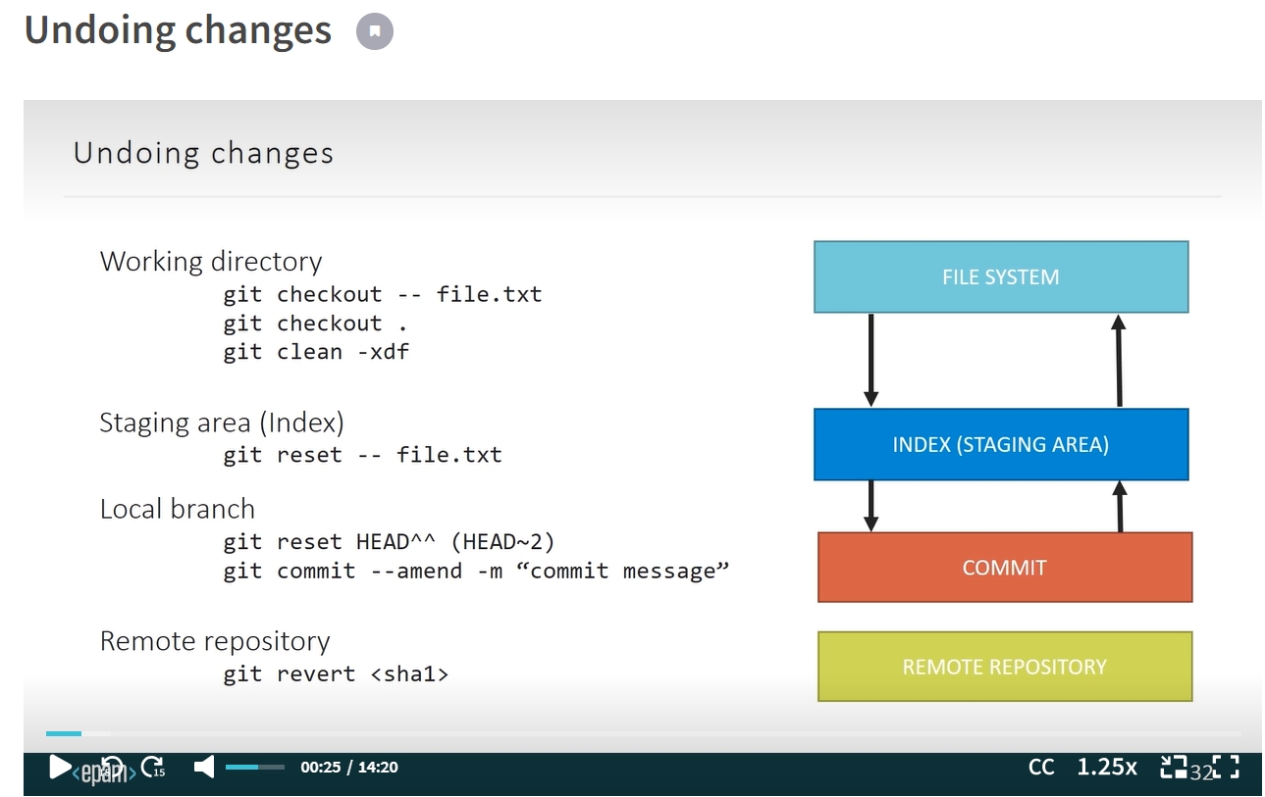

Commands we can use:

1. To undo change from one file : git checkout --<<file name>>
2. To undo change from all file : git checkout . [Note: we can redo changes once we hit this command]
3. To delete or clean some files which recently added or not committed to git before we use: git clean -xdf